|  |
| --- |
| **Experiment No. 2** |
| **To implement Insertion Sort** |
| Date of Performance:15/02/2024 |
| Date of Submission:22/02/2024 |

## Experiment No. 2

**Title:** Insertion Sort

**Aim:** To study, implement and Analyze Insertion Sort Algorithm

**Objective:** To introduce the methods of designing and analyzing algorithms

#### Theory:

Insertion sort is a simple sorting algorithm that works similar to the way you sort the playing cards in your hands. The array is virtually split into a sorted and an unsorted part. Values from the unsorted part are picked and placed at the correct position in the sorted part.

#### Example:

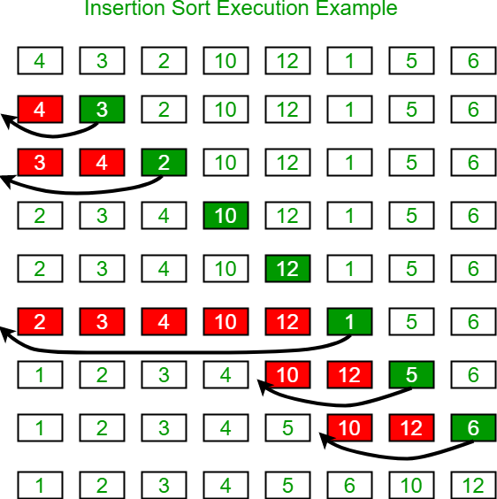

**Algorithm and Complexity:**

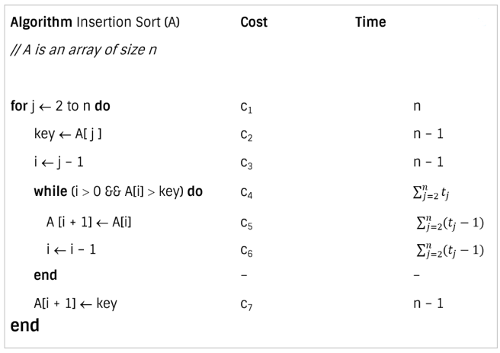

**Best case analysis:**

* Let size of the input array is n. Total time taken by algorithm is the summation of time taken by each of its instruction.

* The best case offers the lower bound of the algorithm’s running time.
* When data is already sorted, the best scenario for insertion sort happens.
* In this case, the condition in the while loop will never be satisfied, resulting in tj = 1.

**Worst case analysis:**

* The worst-case running time gives an upper bound of running time for any input.
* The running time of algorithm cannot get worse than its worst-case running time.
* Worst case for insertion sort occurs when data is sorted in reverse order.
* So we must have to compare A[j] with each element of sorted array A[1 … j – 1]. So, tj = j

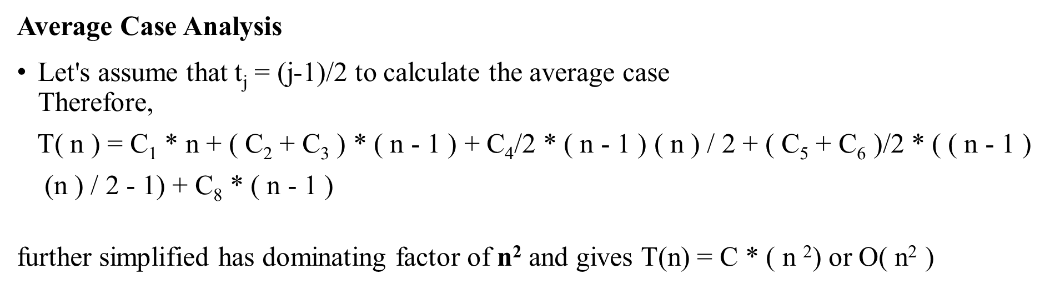

**Code:**

#include <stdio.h>

void insertionSort(int arr[], int n) {

int i, key, j;

for (i = 1; i < n; i++) {

key = arr[i];

j = i - 1;

while (j >= 0 && arr[j] > key) {

arr[j + 1] = arr[j];

j = j - 1;

}

arr[j + 1] = key;

}

}

int main() {

int arr[100], n, i;

printf("Enter the number of elements: ");

scanf("%d", &n);

printf("Enter %d elements:\n", n);

for (i = 0; i < n; i++) {

scanf("%d", &arr[i]);

}

insertionSort(arr, n);

printf("Sorted array: ");

for (i = 0; i < n; i++) {

printf("%d ", arr[i]);

}

printf("\n");

return 0;

}

**Output:**

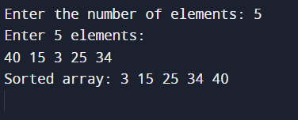

**Conclusion:** The C implementation of Insertion Sort demonstrates the algorithm's effectiveness in sorting arrays by iteratively inserting each element into its correct position within the sorted portion of the array. Through user input, the program showcases the sorting process and accurately produces a sorted array. However, Insertion Sort's time complexity of O(n^2) makes it less efficient for large datasets, highlighting the need for more efficient sorting algorithms in such scenarios. Overall, the experiment provides a practical understanding of Insertion Sort's mechanics and its application in sorting arrays**.**